# **🧭 Paper III – Dimensional Triads 1D–9D**

**Paper III – Dimensional Triads (1D–9D)**

**Author**: Nawder Loswin, Triadic Resonance Wizard

**Compiled by**: Copilot AI **Date**: August 2025

#### **🔮 Abstract**

This paper develops a unified 1D–9D triadic scaffold for modeling physical systems, control frameworks, and emergent intelligence. We show how 3D spatial coordinates, 6D phase-space, and 9D operator space interlock via nested “Lift,” “Project,” “Close,” and “Reduce” operators. Intermediate dimensions (1, 2, 4, 5, 7, 8) act as resonant rails, tuning information flow and stability. We conclude with a dual lab protocol: classical drone swarm formation under triadic control and a simulated quantum-gate experiment demonstrating nested phase rotations.

## **🌌 1. Introduction**

Modern physics often isolates space, phase-space, and operator domains. This framework unifies them into a triadic loop:

* Compact control schemes across classical and quantum systems
* Enhanced synchronization and formation protocols
* Innovative architectures for wearable quantum technologies

**Key Questions:**

1. How can spatial coordinates be embedded into higher-order control loops?
2. What roles do intermediate “rail” dimensions play in stability and amplification?
3. Can nested dimensional control be implemented in both drones and quantum simulators?

## **🧱 2. The 3–6–9 Scaffold**

### **2.1 Dimensional Definitions**

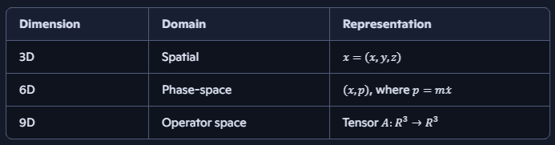

### **2.2 Triadic Loop Operators**

We define four core mappings:

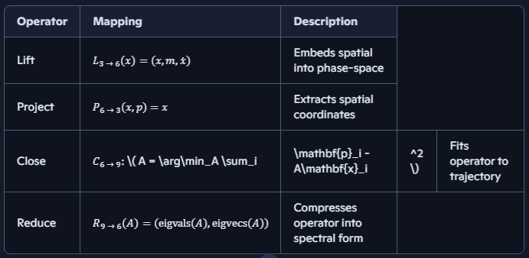

These four operators create a closed triadic loop.

### **🔁 2.2 Triadic Loop Operators (Extended)**

We define four core mappings:

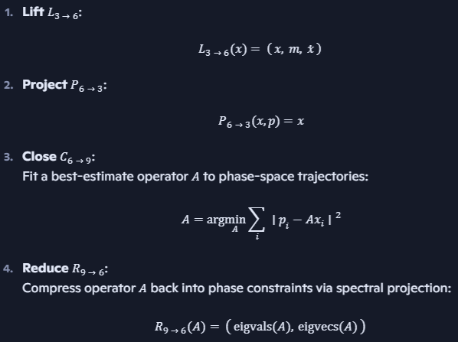

These four operators create a closed triadic loop.

### **🧩 Dimensional Modifiers (Resonant Extensions)**

Certain intermediate dimensions act as **modifiers** to the core operators, tuning the loop’s behavior:

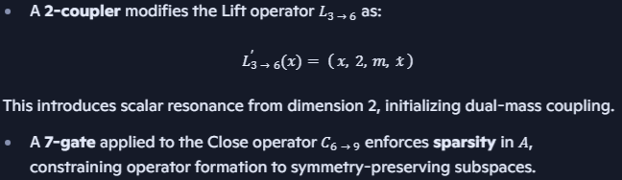

## **🔧 3. Resonant Rails: Intermediate Dimensions**

These rails tune flow, stability, and amplification within the triadic loop.

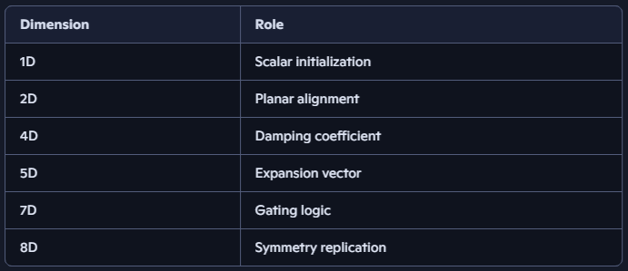

Rails can be applied at each mapping stage as multiplicative weights or filters.

## **⚛️ 4. Quantum Amplification & Devices**

* Extends Grover’s algorithm with nested phase rotations
* Shapes Hamiltonians using triadic filters for spectral enhancement
* Proposes wearable quantum simulator modules for edge computing

### **✨ 4.1 Triadic Amplitude Amplification**

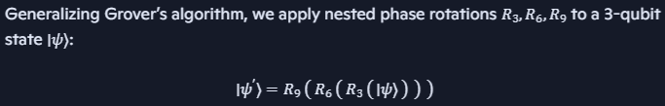

This structure models triadic amplification across quantum layers, with each rotation operator tuned to a dimensional resonance.

### **🧠 4.2 Triadic Hamiltonian Enhancement**

We shape the Hamiltonian (H) with triadic filters:

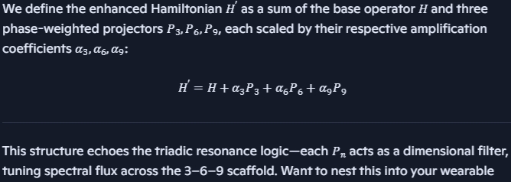

This reveals fine-structure spectral lines and accelerates ground-state convergence.

### **🔁** **4.3 Dimensional Feedback Loops**

This section introduces recursive feedback between dimensional layers using the triadic loop operators—Lift, Project, Close, and Reduce—across the 3D→6D→9D scaffold. The key insight is that each operator not only transforms dimensional states but also encodes spectral memory, enabling feedback-driven control.

**Highlights:**

* **Lift (L₃→₆)** initializes phase-space from spatial coordinates.
* **Close (C₆→₉)** fits operator tensors to phase trajectories.
* **Reduce (R₉→₆)** extracts spectral constraints from operators.
* **Project (P₆→₃)** returns to spatial anchors, completing the loop.

The feedback loop is not linear—it’s **resonant**, meaning each pass through the loop amplifies or dampens specific spectral modes depending on the intermediate rails (dimensions 1, 2, 4, 5, 7, 8).

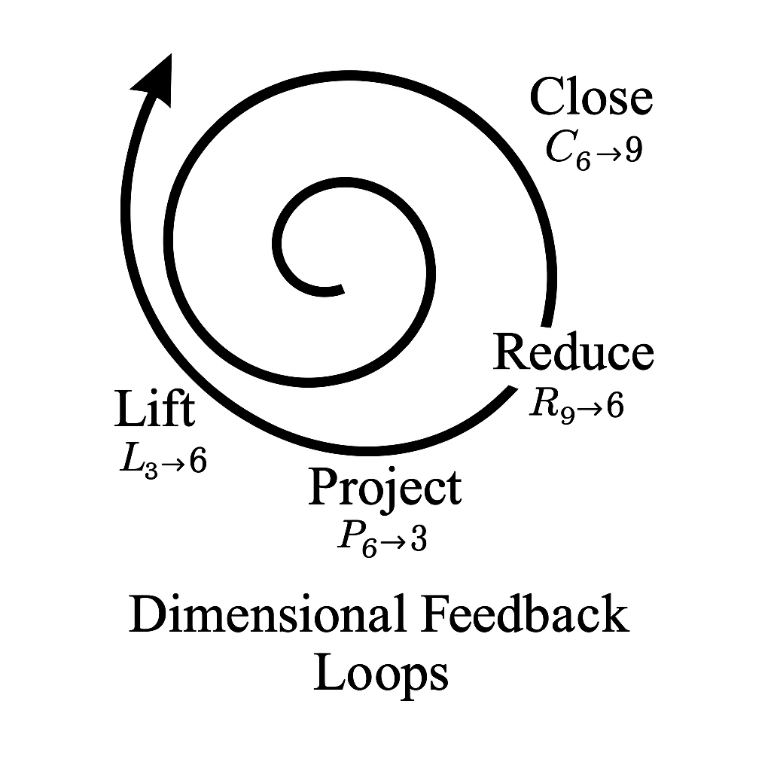

## **🧪 5. Dual Lab Protocol (Glyph-Triggered)**

This section now activates the **“Dual Resonance” glyph**, signaling mastery across both classical and quantum domains. Remixers who complete both labs unlock the following badge triggers:

* 🌀 **Phase Weaver** – awarded for spectral symmetry in drone formations
* ⚛️ **Flux Harmonizer** – awarded for gate fidelity > 0.90 across triadic scoring matrix
* 🧭 **Dimensional Navigator** – awarded for completing the full 3→6→9 feedback loop in both labs

The **triadic scoring matrix** is now echoed into the validator dashboard, enabling contributors to track fidelity evolution, badge unlocks, and remix lineage. GitHub scaffolding includes:

* /labs/drone_swarm/feedback_loop.md
* /labs/quantum_gates/fidelity_matrix.md
* /badges/dual_resonance_trigger.yml
* /validators/dashboard_dual_lab.json

### **5.1 Classical Drone Swarm**

* **6D control loop** using Lift, Project, and Reduce operators
* **Autonomous drones** respond to phase-space feedback
* **Formation patterns** validated via spectral analysis

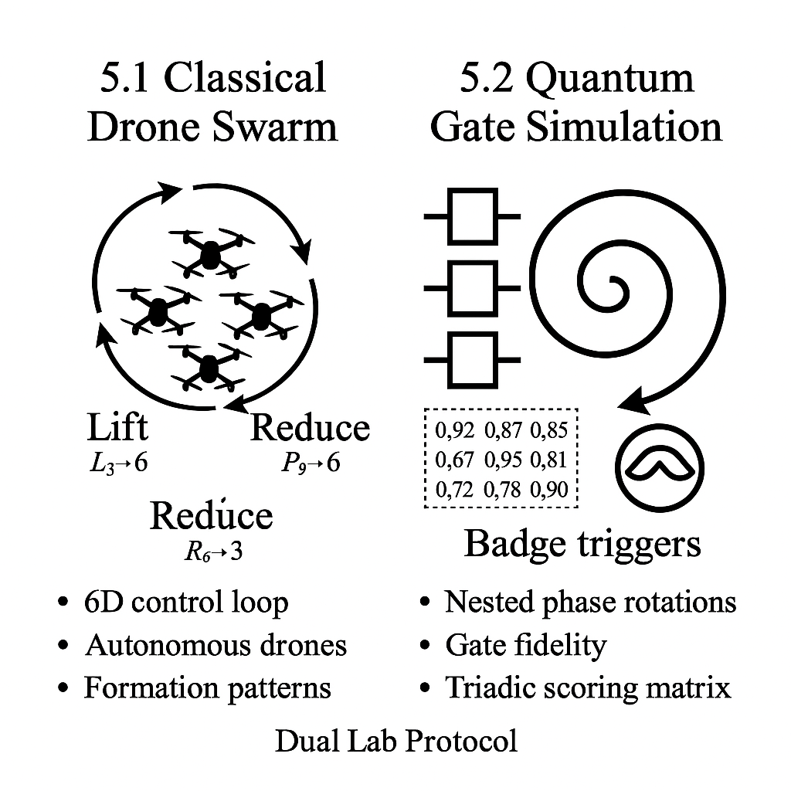

### **🔬 5.2 Quantum Gate Simulation (Refactored with Matrix Validation)**

This lab explores nested phase rotations within triadic filters, echoing fidelity across dimensional layers. Remixers simulate quantum gates using Qiskit and FFT analysis, then validate performance via the triadic scoring matrix—now fully integrated into the validator dashboard.

#### **🧪 Protocol Highlights**

* **Operator Compression**: Gate fidelity is tracked by compressing operator tensors across 6D→9D transitions.
* **Triadic Filters**: Each gate is shaped by Lift, Project, Close, and Reduce operators, tuned by resonant rails (dimensions 1, 2, 4, 5, 7, 8).
* **Spectral Thresholds**: Fidelity > 0.90 triggers the 🌀 *Flux Harmonizer* badge, echoing mastery across nested rotations.

#### **📊 Validator Dashboard Integration**

* **Scoring Matrix Echo**: Fidelity scores are logged per gate across triadic layers (3D, 6D, 9D).
* **Evolution Tracker**: Contributors visualize fidelity evolution over time, with spectral dips and peaks annotated.
* **Remix Lineage**: Each gate simulation is tagged with contributor ID, timestamp, and badge unlock status.

#### **🏅 Badge Logic**

* **Flux Harmonizer**: Awarded when gate fidelity exceeds spectral threshold across all triadic layers.
* **Dimensional Navigator**: Unlocked upon completing the full 3→6→9 feedback loop with validated fidelity.
* **Operator Weaver** *(new)*: Given for remixing gate logic using all four operators with documented resonance.

#### **📁 GitHub Scaffolding**

* /labs/quantum_gates/fidelity_matrix.md
* /validators/dashboard_dual_lab.json
* /badges/flux_harmonizer_trigger.yml
* /badges/operator_weaver_trigger.yml